**Health Data Analysis in Pakistan:**

After making data visualizations in the form of pivot tables in Excel we derive the following insights:

1. Hospital Statistics: What is the distribution of patients across different hospitals?
2. Disease Frequency: What are the most common diseases treated in these hospitals?

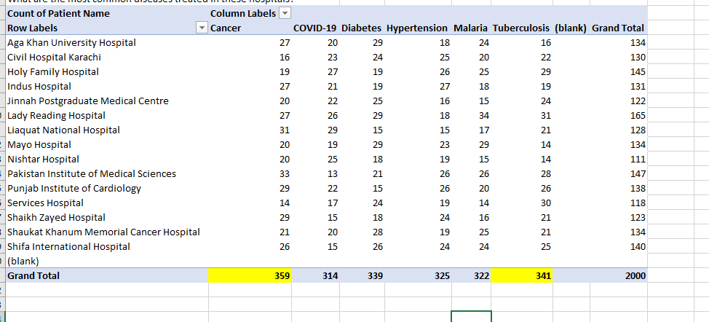

1. Age Distribution: What is the age distribution of patients in each hospital?
2. Gender Ratio: What is the gender ratio of patients for each disease?
3. Treatment Cost Analysis: What is the average treatment cost for each disease?
4. Insurance Coverage: What percentage of patients had insurance coverage?
5. Blood Group Distribution: What is the distribution of blood groups among the patients?
6. City-wise Patient Count: How many patients are from each city?
7. Province-wise Patient Count: How many patients are from each province?

10. Admission and Discharge Dates: What are the peak times for admissions and discharges

in each hospital?

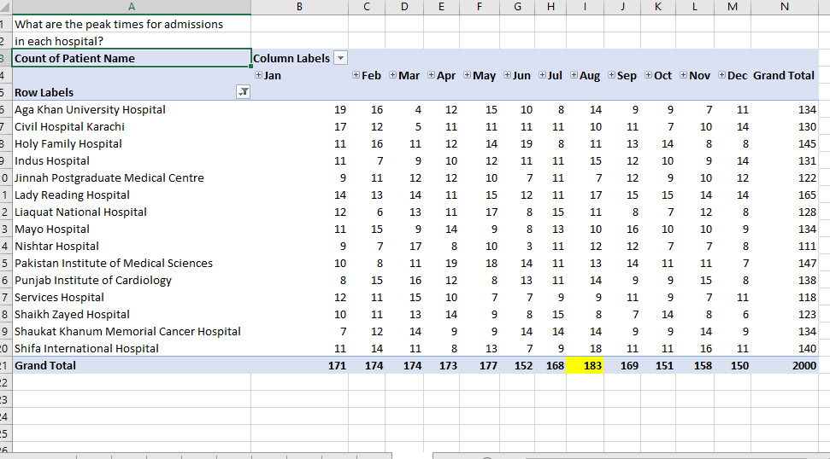

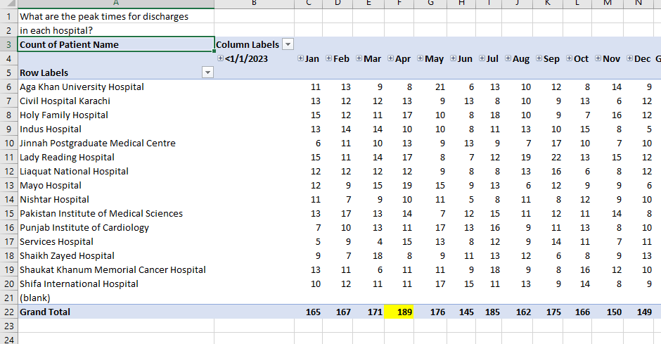

11. Height and Weight Statistics: What is the average height and weight of patients in each

hospital?

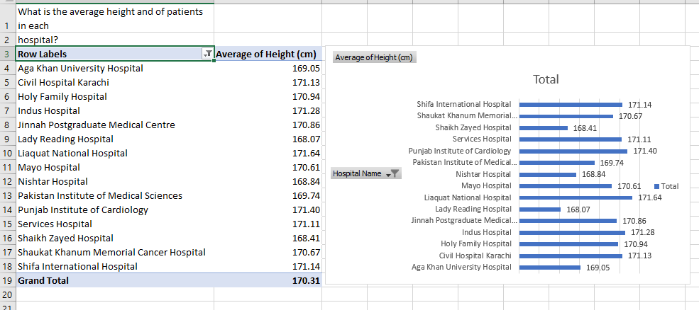

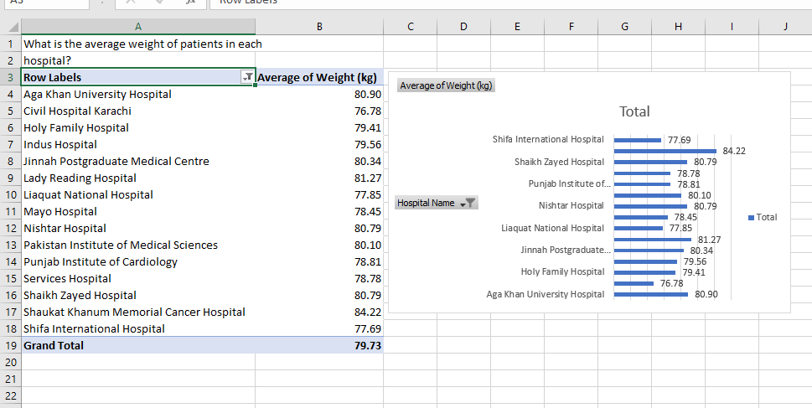

12. Treatment Cost by Hospital: How does the average treatment cost vary across different

hospitals?

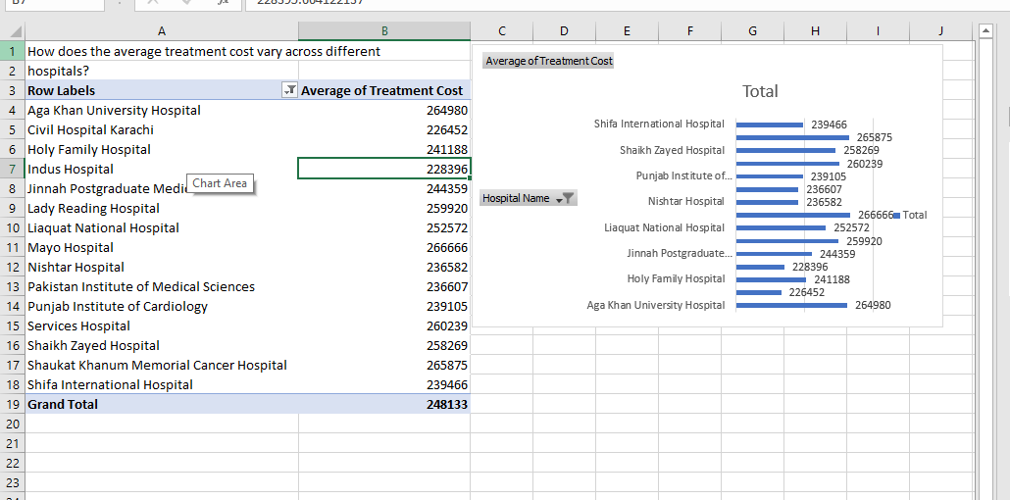

13. Patient Age vs. Treatment Cost: Is there a correlation between the age of patients and

the treatment cost?

15. Patient Age vs. Treatment Cost: Is there a correlation between the age of patients and

the treatment cost?

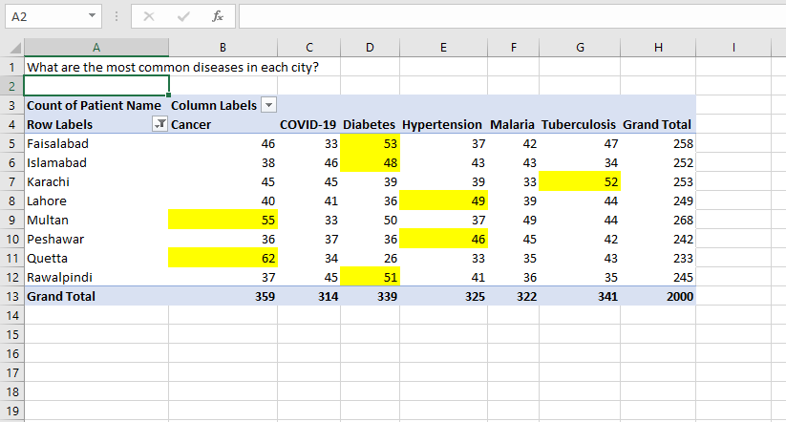

16. Disease by City: What are the most common diseases in each city?

17. Hospital Performance: Which hospital has the highest average treatment cost and which

has the lowest?

